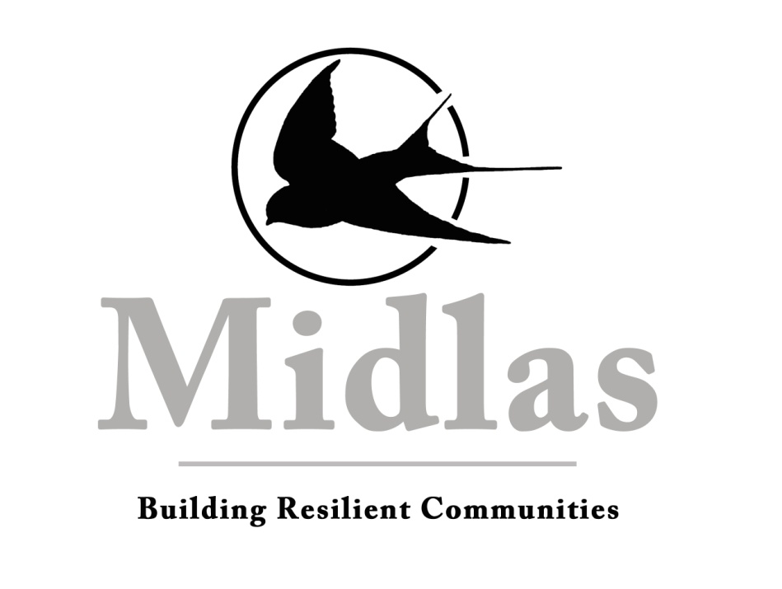

Schedule B – Position Description

Organisation Midland Information Debt and Legal Advocacy Service Inc. (Midlas)

Position Title Principal Solicitor
Department Legal Services
Reporting To CEO
Direct Reports Lawyers, Legal Volunteers
Vision Building Resilient Communities
Mission We partner with individuals and organisations to promote independence, strength and wellbeing in our community through support, advocacy and education
Values Caring for people
Developing Partnerships
Supporting our Community
Location 23 Old Great Northern Highway Midland WA 6056

Midlas is an Equal Opportunity Employer
This position is subject to continued funding

KEY RESPONSIBILITIES
- Provide advice and assistance to victims of family and domestic violence;
- Provide a family law service and criminal injuries compensation within the limitations of funding and time restrictions;
- Provide advice and supervision to Midlas tenancy advocates, disability advocates and financial counsellors as appropriate;
- Provide and facilitate community legal education;
- Undertake the role of ‘responsible person’ for the purposes of the Risk Management and Community Legal centre Practice Guide;
- Supervise and train lawyers, law students, legal volunteers and interns;
- Develop and liaise with key stakeholders to ensure good referral pathways, enhanced community education service provision, and optimal client outcomes;
- Play an active and constructive role in the Midlas client services team, working together to achieve the strategic direction of the organisation;
- Ensure that the organisation meets its statutory and contractual obligations.

STATEMENT OF DUTIES
Service Delivery
- Domestic Violence
- Advice and information before the lodging of VRO applications;
- Representation at Mention Hearings;
- Representation at VRO Final Order Hearings;
- Representation at applications to cancel a VRO;
- Preparation of Undertakings for clients;
- Preparation of statements, affidavit evidence and books of documents for trial;
- Assisting clients to relocate and change their names in situations of extreme domestic violence.
- Criminal Injuries Claims
- Criminal Injuries Claims – Minor assistance and case work;
- Preparation of victim impact statements and statements of events.
- Family Law
- Advice on divorce and separation;
- Advice on children’s issues and parental rights and responsibilities;
- Preparing Family Court documentation;
- Preparing letters of advice and general correspondence; and
- Preparing client and witness affidavits.
- Provide emergency relief as appropriate;
- Maintain a high standard of case work management including the provision of timely follow-up actions as required;
- Support team members to ensure that individuals or families receive a holistic service and complex cases are managed appropriately.
Community Engagement
- Maintain and deliver community legal education to facilitate the building of resilient communities;
- Liaise with networks and communities to strengthen our profile and promote sustainable growth;

Leadership and Volunteer Supervision
- Ensure and facilitate appropriate professional development for all legal students, legal volunteers and restricted legal practitioners;
- Create an environment oriented to open communications, creative thinking, cohesive team effort and workplace trust;
- Create a culture that builds individuals skills and shares knowledge;
- Develop and promote consistent and appropriate processes that encourage effective teamwork;
- Provide advice and support to the client services team as appropriate;
- Assist with the recruitment and coordinate the induction and orientation of new legal staff and volunteers.

Administration and Reporting

- Ensure appropriate service delivery in respect to funding and contracts with an emphasis on person-centred integrated service and program standards;
- Support the organisational strategic goals to ensure high quality outcomes are achieved in line with contractual obligations and audit requirements;
- Maintain necessary personal professional development and accreditation requirements;
- Monitor all case work to ensure best practice and adherence to legal requirements and funding body requirements.

Other Duties
- Work in partnership with the General Manager to ensure that there is consistency, continuous improvement and cohesiveness within the client services team;
- Support and work in accordance with Midlas policies and procedures;
- Support the organisational strategic focus and objectives;
- Other duties as directed by management.

SELECTION CRITERIA
Essential
- Experienced Lawyer with a current Unrestricted Practising Certificate
- Understanding of and current expertise in relevant areas of law and practice
- Strong organisational and time management skills, including ability to manage competing demands, prioritise tasks and solve problems
- Self-motivated and managing, able to work independently and proactively
- Ability to identify broader and systemic issues arising from casework and to propose relevant responses, and
- Demonstrated commitment to social justice, understanding of the community legal sector, and of the objectives and values of Midlas
Desirable
- Community Legal Centre experience

Special Requirements
Provision of a clear Police clearance certificate.
Limitation of Authority
The Principal Lawyer is authorised to take any reasonable action necessary to achieve the requirements contained in this job description, provided such action is within the framework of policies and procedures of Midlas and any other specific directives of the General Manager.
This Job description works with and relies upon the current separate Key Performance Indicators.

Employee: Date:

CEO: Date:

