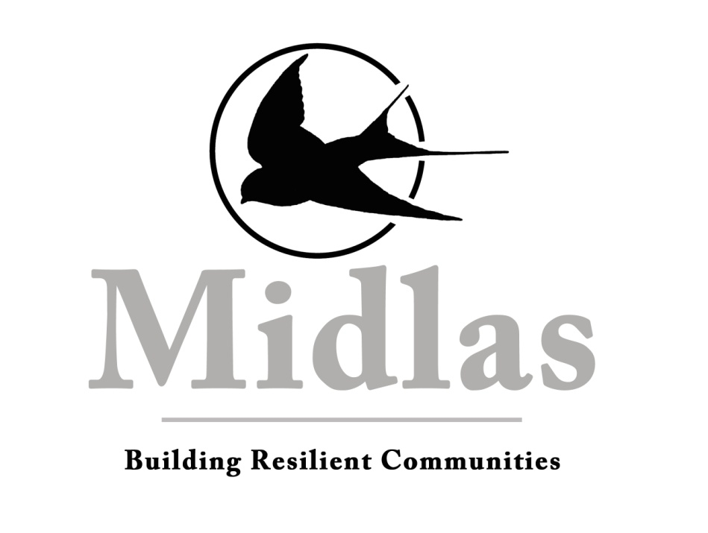

Schedule B – Position Description

Organisation Midland Information Debt and Legal Advocacy Service Inc (Midlas)

Position Title Disability Advocate
Award SACS Level 4.1
Department Disability Services
Reporting To Disability Discrimination Lawyer
Vision Building Resilient Communities
Mission We partner with individuals and organisations to promote independence, strength and wellbeing in our community through support, advocacy and education
Values Caring for people
Developing Partnerships
Supporting our Community
Location 23 Old Great Northern Highway Midland WA 6056

Midlas is an Equal Opportunity Employer
This position is subject to continued funding

KEY RESPONSIBILITIES
- Provide best practice advocacy services for people with disabilities;
- Work closely with the NDIA (National Disability Insurance Agency ) and Department of Communities (WA NDIS), SAT (State Administrative Tribunal), AAT (Appeals Administrative Tribunal) and other disability agencies to ensure individuals, carers and families in our region, rights, participation and goals are promoted;
- Develop and liaise with key stakeholders to ensure good referral pathways, enhanced service provision and optimal client outcomes;
- Devise, organise and present community education to raise awareness of disability issues and build community capacity;
- Play an active and constructive role in the Midlas client services team, working together to achieve the strategic direction of the organisation;
- Ensure that the organisation meets its statutory and contractual obligations.

STATEMENT OF DUTIES
Service Delivery
- Conduct assessments with individuals, carers and families, providing advocacy and facilitating self-advocacy and independence;
- Work collaboratively with individuals, carers and families to develop action plans;
- Provide information, advocacy, support, negotiation, options and appropriate referrals;
- Provide advocacy support and representation at external meetings, mediation, the SAT and AAT and other agencies;
- Provide emergency relief as appropriate;
- Maintain a high standard of case work management including provision of timely follow-up actions as required;
- Support team members to ensure that individuals or families receive a holistic service and complex cases are managed appropriately.

Community Engagement
- Survey the community on levels of awareness of service provision and issues relevant to the client group;
- Devise strategies and deliver community education on building resilient communities to reduce gaps and promote independence for individuals, carers and families within the client group;
- Liaise with networks and communities to strengthen our profile and promote sustainable growth;
- Regularly contribute information, trends and articles relevant to the disability sector and building capacity in the disability community for Midlas to produce in its media content;

Administration and Reporting
- Keep accurate records and comprehensive database entries;
- Undertake quantitative and qualitative reporting to the Board, Midlas management team, funding bodies and other agencies as required;
- Contribute to preparation of funding submissions;
- Undertake regular internal and external quality audits and file reviews;
- Regularly review, update and adhere to the Midlas Disability Access and Inclusion Plan;
- Maintain an updated disability services resource and referral file;
- Adhere to the National Standards for Disability Services (NSDS);
- Operate within the disability program budget.

Other Duties
- Work in partnership with the client services team to ensure that there is consistency, continuous improvement and cohesiveness within the client services team;
- Support and work in accordance with Midlas policies and procedures;
- Support the organisational strategic focus and objectives;
- Other duties as directed by management.

SELECTION CRITERIA
Essential
- Demonstrated high level of communication skills, both written and oral, including interpersonal, negotiation and client centred advocacy skills;
- Knowledge and experience of disability services and the issues impacting upon people with disabilities;
- Relevant professional qualification and /or experience in service area.
Desirable
- Ability to prepare and present community education and to raise public awareness on relevant issues;
- Knowledge of Federal and State legislation and regulations relevant to people with disabilities;
- Valid Australian driver’s licence and personal vehicle with comprehensive car insurance.

Special Requirements
Provision of a clear Police clearance certificate

Limitation of Authority
The Disability Advocate is authorised to take any reasonable action necessary to achieve the requirements contained in this job description, provided such action is within the framework of policies and procedures of Midlas and any other specific directives of the Chief Executive Officer.
This Job description works with and relies upon the current separate Key Performance Indicators.

Chief Executive Officer: Date:

Employee: Date:

