2018 Midlas Values Award
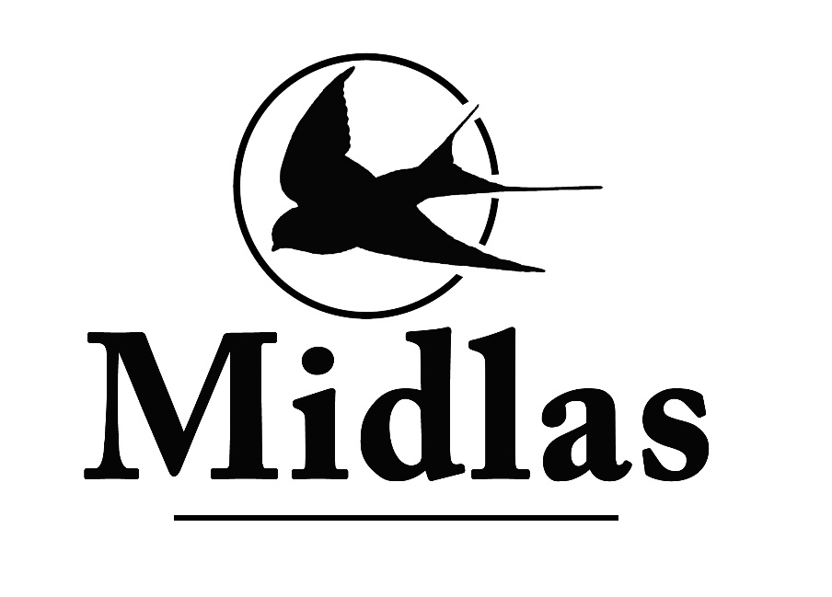
Nomination Form

Midlas’ Annual Values Award is a way to recognise Midlas staff and Volunteers who do a great job in reflecting our values of Caring for people, Developing partnerships, and Supporting our community. We are asking clients, visitors, staff and families, to please nominate a staff member who you think does a wonderful job in reflecting these values, and we will recognise their amazing effort at our AGM in November.

Nominee: _______________________________________________
Job Title: ________________________________________________
Nominator: _______________________________________________
Relationship to nominee: Colleague Supervisor Client/ Family Midlas Visitor

Midlas’ values are Caring for people, Supporting our community and Developing partnerships How does the nominee demonstrate one or all of these values?

Describe the ‘Wow’ factor this person brings to Midlas

Please give any other information you think will help the judges to decide

Please have all applications submitted to the Chair, Danielle Bejr by no later than 30 October 2018, you can do this by dropping at the counter, or emailing your nomination to danielle.bejr@midlas.org.au

Thank you for your nomination!

