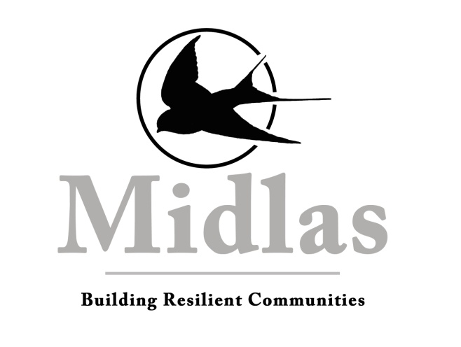

Client Privacy Policy

Policy Connections
This policy is compliant with the National Standards for Disability Services (NSDS) – Standard 1 Rights, and the NACLC accreditation scheme.
Other legislation connections: Disability Services Act (1986), and Disability Discrimination Act (1992).

Client Privacy
Midlas recognises the importance of protecting the privacy of personally identifiable information collected about our clients and is committed to protecting and upholding the right to privacy of clients. For the purposes of this Privacy Policy, the word "clients" includes users of our services, visitors to our web site and representatives of agencies we deal with.
Midlas is bound by Australian Privacy Principles (APP), under the Privacy Act 1988, which impose specific obligations when it comes to handling information.
Midlas will:
- not collect personal information unless we consider it necessary for us to provide services;
- not use or disclose personal information about an individual for a purpose other than:
  - the purpose for which it was collected;
  - a related purpose (or, in the case of sensitive information, a “directly related” purpose) which the individual would reasonably expect;
  - a purpose required or permitted by law; or
  - a purpose for which we have obtained the consent of the individual.
- take all reasonable steps to make sure that the personal information we collect, use or disclose is accurate and up to date;
- take all reasonable steps to protect and safeguard the personal information we collect;
- make available our policies on our management of personal information;
- provide individuals with access to their personal information that we hold, except where we are required or entitled by law to refuse access.

Collection of Personal Information
Midlas will only collect personal information if it is necessary for us to do so. Situations in which we may collect personal information include, but are not limited to:
- obtaining oral instructions from you regarding your legal, financial, tenancy or disability problem;
- obtaining documentation from you concerning your legal, financial, tenancy or disability problem;
- communication with third parties where you have instructed us to communicate with third parties;
- when processing membership application forms and any subsequent amendments to members’ details;
- when dealing with any request or application for products or services;
- when presenting seminars, conducting workshops or other functions;
- when dealing with certain government agencies;
- when required by law;
- when dealing with individuals who contact us regarding our activities or the activities of our members.
Personal information may include sensitive information as defined in the Privacy Act 1988 (for example, information about your racial or ethnic origin, sexual orientation or practices (only where indicated as relevant to your case), your criminal record (only where indicated as relevant to your case) and health information about you.

Types of Personal Information
We collect personal information in person, in writing, by telephone, through our website and through other methods of communication with our members, clients and other individuals we deal with.
Our members provide personal information to us when they apply for or renew membership.
Our clients provide personal information to us over the telephone to Midlas, when they become a client of Midlas or when they explain their circumstances to Midlas via another medium.
Midlas occasionally receives information from third parties (such as refuges and the Family Violence Service) regarding potential clients. It is presumed that the potential clients have provided their consent for the third party to provide Midlas with information.
When Midlas collects personal information before or after a person becomes a client of Midlas, that information may be linked electronically to a ‘contact’ in the Midlas electronic storage system. If information including sensitive information is held by Midlas concerning the client or potential client it is likely that reference will be made to that information by Midlas staff.
Often Midlas may need to collect personal information from third parties in relation to your case or in relation to membership applications, in the course of carrying out our responsibilities, ensuring that information that we have been given is correct.
These third parties may include:
- the other party or parties to litigation or to a dispute;
- court and tribunal services;
- banks or financial institutions;
- credit card providers;
- credit services providers;
- disability services providers;
- insurance providers;
- utility providers including electricity and gas providers;
- telephone services providers;
- landlords and their agents; and
- government departments.
In each case, we will treat personal information we collect in accordance with the principles set out above.

Personal information uses
Midlas takes several steps to ensure the security of client information and to manage risks. These measures include:
- password protection of all computers;
- files are stored in a lockable filing cabinet;
- monitoring of internal staff;
- external auditing; and
- external cross checks by other Community Legal Centres.
We use personal information to maintain membership records, provide information and enable clients to resolve their issues. Midlas will use your personal information to conduct research in order to identify and analyse the ongoing needs of clients and the community in the north east region of Perth, Western Australia and Australia.
Midlas is a member of the National Association of Community Legal Centre (NACLC) and Community Legal Centres’ Association (WA) (CLCWA) and is required to undergo annual cross checks for the purpose of compliance. Personal information from your file may be reviewed as part of the annual cross check.
Midlas receives grants from the Commonwealth and State Government as well as other charitable institutions and has reporting and audit requirements to these organisations. Your file may be reviewed to ensure compliance or personal information from your file may be used as part of reporting requirements by the granting entities.
In addition, to satisfy regulatory requirements, Midlas uses personal information to carry out administrative tasks and manage our clients rights and obligations in relation to external obligations and statutory obligations as required.

Information disclosure
Midlas may disclose your personal information to third parties. These may include our agents, our contractors (including organisations used by us, such as “cloud data storage contractors, to store information in an electronic format), insurers, advisors, your agents, your contractors, members’ employers and other entities. We will only do so in accordance with the Privacy Act 1988 and our policy. Midlas also stores archived files with third party storage providers which may change from time to time.
If Midlas is provided with unsolicited information, Midlas will not release that unsolicited information to any third party without the express permission of the person providing that information.

Collection
Midlas will start to collect your personal information when you first contact us by telephone, email, letter, in person or through another medium. The usual procedure is that you will book an appointment to see one of our advocates, and at that stage we will take reasonable steps to ensure that a client is aware of:
- who we are and our full contact details;
- the fact that person is able to gain access to the personal information that we collect and seek the correction of such information;
- the purposes for which the personal information is collected;
- the organisations (or types of organisations) we will usually disclose or transfer that personal information to;
- whether it is likely that we will disclose information to overseas recipients and if so, where;
- any law which requires us to collect the personal information;
- the main consequences (if any) if all (or part) of the personal information requested by us is not provided.
However, there are circumstances where we are not required to do so.

Client access to personal information
Requests for access to your personal information should be made in writing to our Chief Executive Officer (CEO).
Under the APP, you have the option of not identifying yourself, or of using a pseudonym, when dealing with Midlas in relation to a particular matter unless Midlas is required or authorised by or under an Australian law, or a court/tribunal order, to deal with individuals who have identified themselves or it is impracticable for the Midlas to deal with you if you not identified themselves or who have used a pseudonym. Midlas anticipates that clients of Midlas will have to identify themselves before information is provided as Midlas will not be able to identify clients if they do not identify themselves or use a pseudonym.
If you request, then in most circumstances we will make available to you the personal information about you that we have collected. In certain circumstances we might not allow you access to your personal information. These circumstances include, where:
- it would have an unreasonable impact on the privacy of others;
- the information relates to legal proceedings with you;
- the information would reveal our commercially sensitive decision-making process;
- providing access to the information would prejudice certain investigations;
- we are required by law not to disclose the information. This includes duties we may have under common law.
We will respond to a request for access to information as a priority and will seek to do so within a maximum of 10 days. We will not charge you for requesting access to your own personal information.
If you believe that any information that we hold about you is inaccurate or out of date, please contact us and we will review and update the relevant information. We encourage our members and clients to access and update personal membership information should they believe it to be incorrect.

Dissatisfaction with information retention
Midlas wants to improve our systems and procedures to give you full confidence in our ability to respect and safeguard the privacy of the personal information you provide to us. If we have not fulfilled our commitment to you, please tell us by contacting our CEO.

