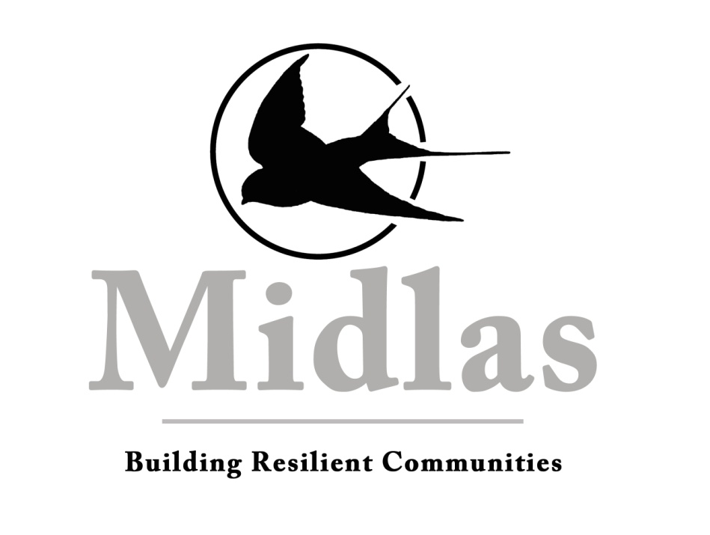

Schedule B – Position Description

Organisation Midland Information Debt and Legal Advocacy Service Inc (Midlas)

Position Title Tenancy Advocate
Department Tenancy Services
Reporting To Financial Counselling and Tenancy Services Senior
Vision Building Resilient Communities
Mission We partner with individuals and organisations to promote independence, strength and wellbeing in our community through support, advocacy and education
Values Caring for people
Developing Partnerships
Supporting our Community
Location 23 Old Great Northern Highway Midland WA 6056

Midlas is an Equal Opportunity Employer
This position is subject to continued funding

KEY RESPONSIBILITIES
- Provide best practice advocacy services to people with residential tenancy issues;
- Work closely with Department of Commerce, Tenancy WA and other local service units;
- Develop and liaise with key stakeholders to ensure good referral pathways, enhanced service provision and optimal client outcomes;
- Devise, organise and present community education to raise awareness regarding tenants rights and responsibilities as set out under Residential Tenancies Act (1987);
- Play an active and constructive role in the Midlas client services team, working together to achieve the strategic direction of the organisation;
- Ensure that the organisation meets its statutory and contractual obligations.
STATEMENT OF DUTIES
Service Delivery
- Conduct assessments with individuals and families, providing advocacy and facilitating self advocacy and independence;
- Work collaboratively with individuals and families to develop action plans;
- Provide general minor assistance, information, advocacy, support, negotiation, options and appropriate referrals;
- Provide advocacy support and representation at external meetings, regional appeal committee hearings and local magistrates court;
- Provide emergency relief as appropriate;
- Maintain a high standard of case work management including providing timely follow-up of actions as required;
- Support team members to ensure that a holistic service and complex cases are managed appropriately for the individual or family.
Community Engagement
- Deliver and monitor the effectiveness of, targeted community education programs on issues relating to tenants rights and responsibilities to build resilient communities;
- Liaise with networks and communities to strengthen our profile and promote sustainable growth;
- Regularly contribute information, trends and articles relevant to the law and issues impacting on tenancies, in order to promote capacity building in the community, for Midlas to produce in its media content.
Administration and Reporting
- Keep accurate records and comprehensive database entries;
- Undertake quantitative and qualitative reporting to the Board, Midlas management team, funding bodies and other agencies as required;
- Undertake regular internal quality audits and file reviews;
- Be aware of and adhere to the Midlas Disability Access and Inclusion Plan;
- Maintain an updated tenancy services resource and referral file;
- Operate within the tenancy program budget.

Other Duties
- Work in partnership with the client services team to ensure that there is consistency, continuous improvement and cohesiveness in the workplace;
- Support and work in accordance with Midlas policies and procedures;
- Support the organisational strategic focus and objectives;
- Other duties as directed by management.
SELECTION CRITERIA
Essential
- Demonstrated high level of communication skills, both written and oral, including interpersonal, negotiation and client centred advocacy skills;
- Knowledge and experience of the Residential Tenancies Act (1987) and other relevant legislation;
- Previous experience in tenancy advocacy and/or community services.

Desirable
- Ability to prepare and present community education and to raise public awareness on relevant issues;
- Knowledge and experience of financial literacy and capability tools.

Special Requirements
Provision of a clear Police clearance certificate.
Limitation of Authority
The Tenancy Advocate is authorised to take any reasonable action necessary to achieve the requirements contained in this job description, provided such action is within the framework of policies and procedures of Midlas and any other specific directives of the General Manager.
This Job description works with and relies upon the current separate Key Performance Indicators.
Employee: Date:

General Manager: Date:

